Meeting and Greeting

1. Say “Hello.”  
   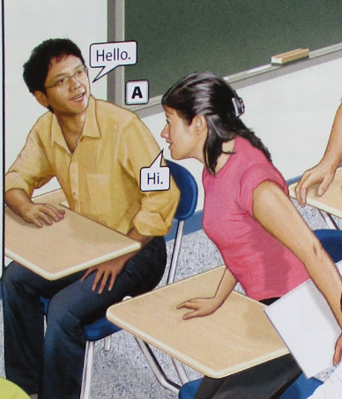  
   Di “Bonjou” oubyen “Bonswa.”
2. Ask, “How are you?”  
   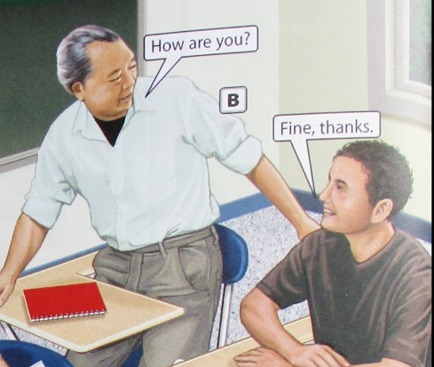  
   Mande “Kouman ou ye?”
3. Introduce yourself.  
   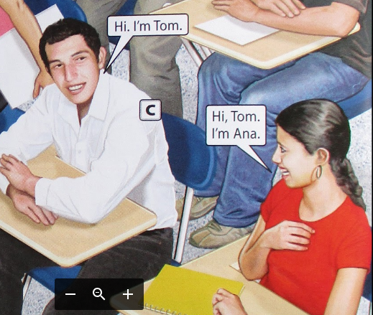  
   Prezante tèt ou.
4. Smile.  
   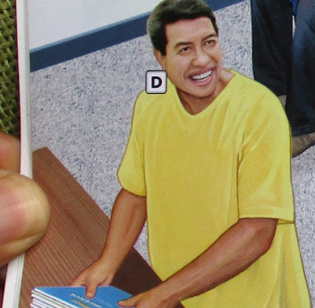  
   Souri.
5. Hug.  
   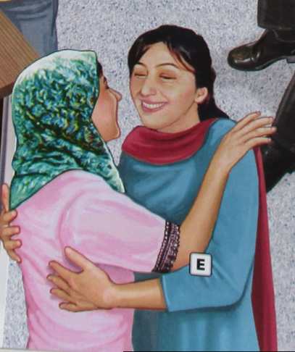

Kwoke.

1. Wave.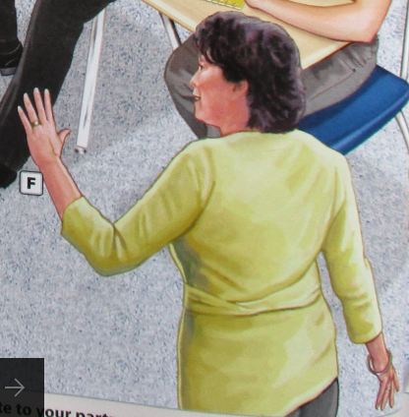Voye men.
2. Greet people.   
   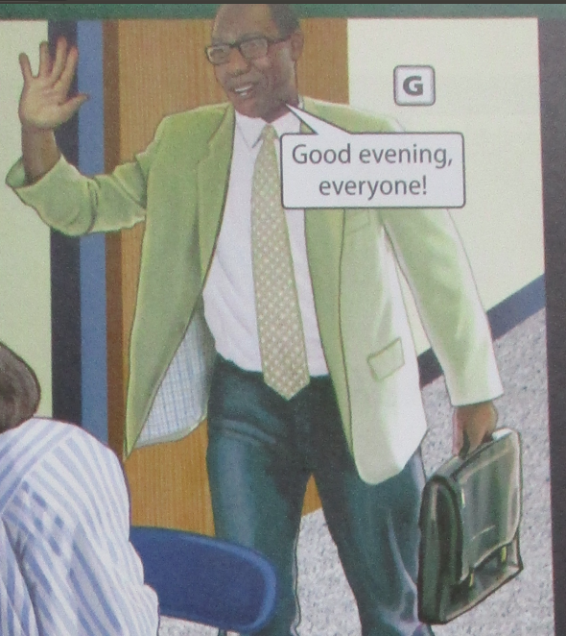  
   Salye moun.
3. Bow.   
   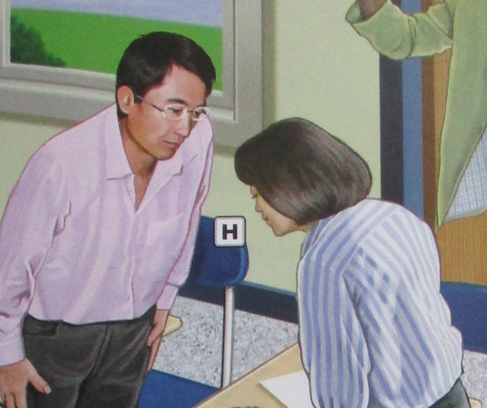

Fè reverans.

1. Introduce a friend.   
   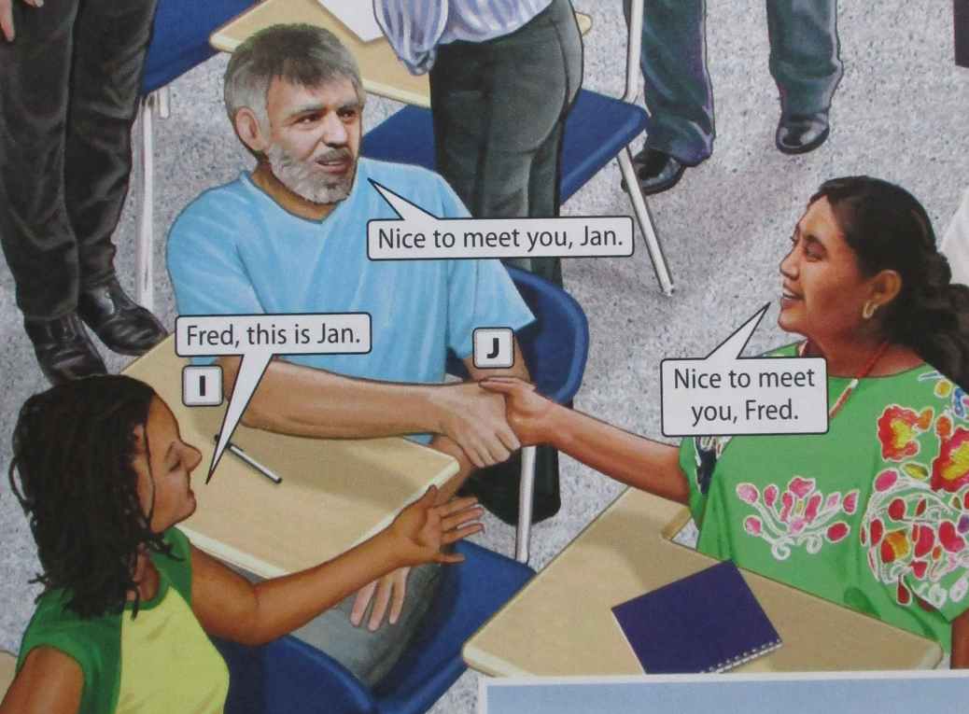  
    Prezante yon zanmi.
2. Shake hands.   
   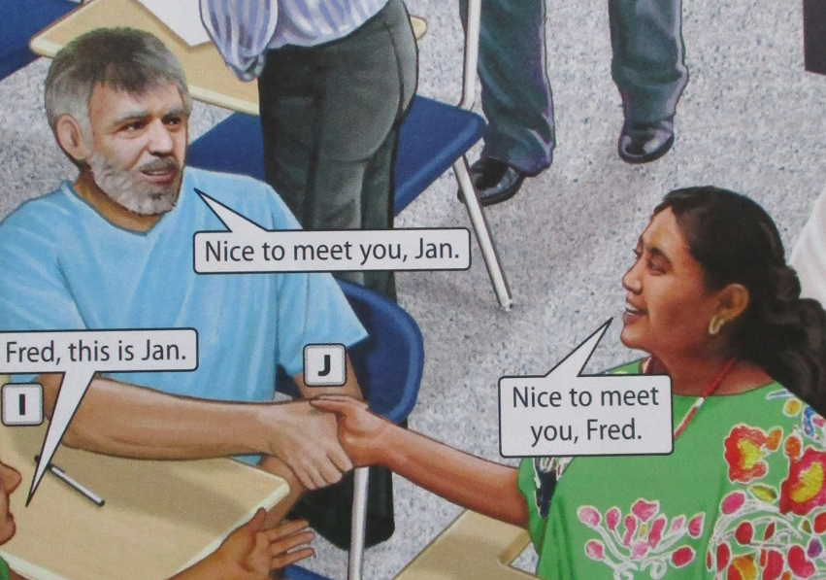  
   Bay lanmen.
3. Kiss.   
   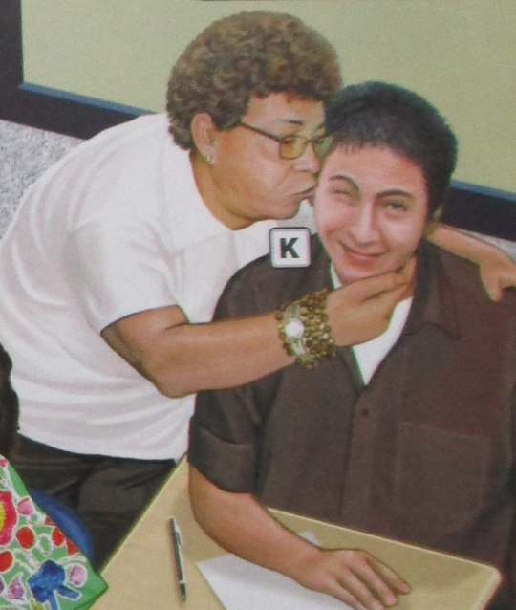  
   Bo.
4. Say “Goodbye”   
   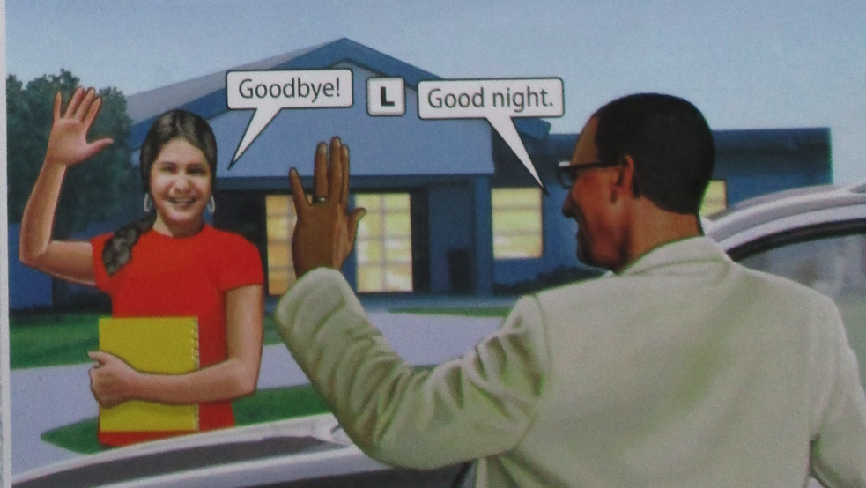  
   Di “Orevwa”